**Design Specifications:**

**ERD:**

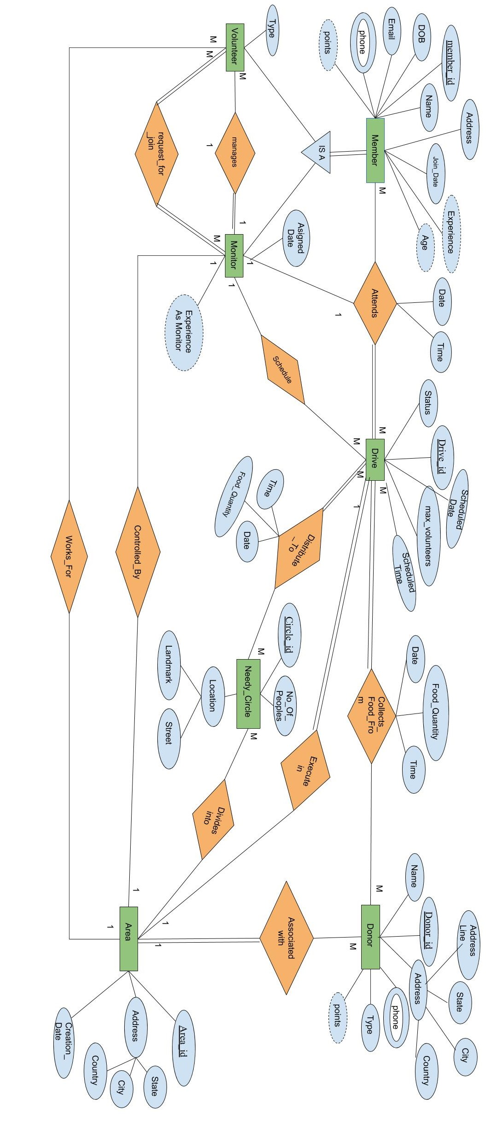

**Schema Diagram:**

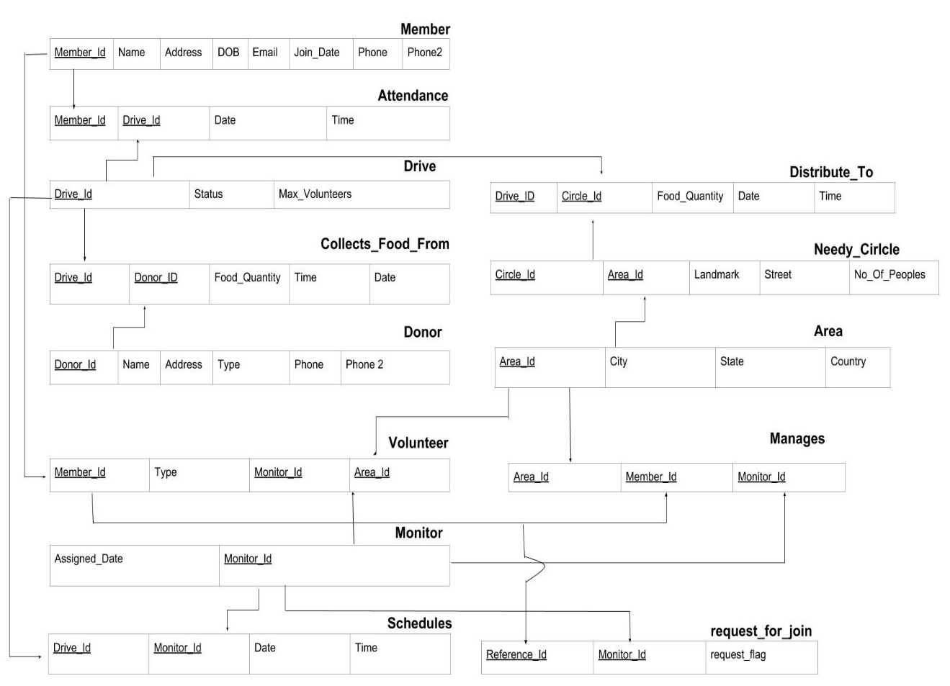

**Use Case:**

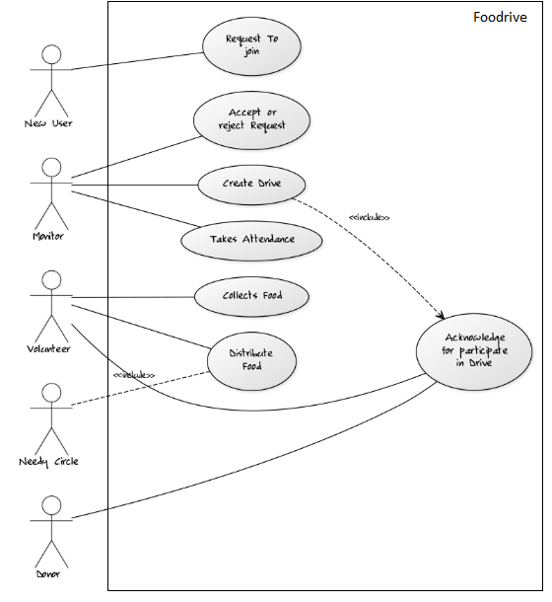

**Requirement**

Software Configuration: -

This software package is developed using Java Swing as front end which is supported NetBeans. Microsoft MySQL Server as the back end to store the database.

Operating System: Windows 8.1

Language: Java Runtime Environment, Net beans 7.0.1 (front end)

Database: MS SQL Server (back end)

Hardware Configuration: -

Processor: Pentium(R) Dual-core CPU

Hard Disk: 40GB

RAM: 256 MB or more

**Data Requirement**

The inputs consist of the query to the database and the output consists of the solutions for the query. The output also includes the user receiving the after drive initiate by monitor. In this project the inputs will be the queries as fired by the monitor like Register/Update a volunteer/donor, delete a volunteer or donor. Details of volunteer/donor will be visible as output in form of frames when a person requests the server to get details of volunteers/donors in his chapter.

**External Interface Requirement**

**GUI**

The software provides good graphical interface for the volunteers/donors to operate on the system, performing the required task such as register, update, delete and to participate and view the live details of the drive.

.

* It allows monitor create drive in his chapter.
* All the modules provided with the software must fit into this graphical user interface and accomplish to the standard defined
* The design should be simple and all the different interfaces should follow a standard template
* The user interface should be able to interact with the volunteer module and a part of the interface must be dedicated to the login/logout module

Login Interface: -

1. Volunteer

In case a person is not yet registered, he can register through Foodrive JoinUs page. After that he will receive the confirmation from its associated chapter monitor.

1. Donor

He is the person who donate the food during drive. Same as volunteer he can join foodrive through joinus page.

Volunteer’s Dashboard -

This control panel will allow a Volunteer to stay updated with monitor’s actions, see the information about drives conducted in his chapter etc.

Donor’s Dashboard: -

This control panel will allow a Donor to donate a food, to see the .drives conducted in his chapter.

**System Features**

The users of the system should be provided the surety that their account is secure. This is possible by providing: -

* Volunteers/Donors authentication and validation of members using their unique ID
* Proper monitoring by the Monitor which includes updating Drive status.

**Other Non-functional Requirements**

**Performance Requirement**

The proposed system that we have developed will be used as the Surplus Food Management system within the country which interacts with Volunteers and Donors across his chapter. Therefore, it is expected that the database would perform functionally all the requirements that are specified.

* The performance of the system should be fast and accurate.
* Surplus Food Management system shall handle expected and non-expected errors in ways that prevent loss in information and long downtime period. Thus, it should have inbuilt error testing to identify invalid username/password
* The system should be able to handle large amount of data. Thus, it should accommodate large number of voters without any fault

**Safety Requirement**

The database may get crashed at any certain time due to virus or operating system failure. Therefore, it is required to take the database backup so that the database is not lost.

**Security Requirement**

* System will use secured database
* Normal users can just read information but they cannot edit or modify anything own their own and changes can only be made after following some process.
* System will have different types of users.
* Proper user authentication should be provided
* No one should be able to hack users’ password

**Requirement attributes**

* The project should be open source
* The Quality of the database is maintained in such a way so that it can be very user friendly to all the users of the database
* The user can easily download and install the system.

**Business Rules**

A business rule is anything that captures and implements business policies and practices. A rule can enforce business policy, decide, or infer new data from existing data. This includes the rules and regulations that the System users should abide by. This includes the cost of the project and the discount offers provided. The users should avoid illegal rules and protocols. Neither admin nor member should cross the rules and regulations.

**User Requirement**

The users of the system are Volunteers, Donors and Monior who act as administrator to maintain the system. The members are assumed to have basic knowledge of the computers and internet browsing. The administrators of the system should have more knowledge of the internals of the system and is able to rectify the small problems that may arise due to disk crashes, power failures and other catastrophes to maintain the system. The proper user interface, user manual, online help and the guide to install and maintain the system must be sufficient to educate the users on how to use the system without any problems.

The system provides certain facilities to the users in the form of: -

* Backup and Recovery
* Data migration i.e. whenever user registers for the first time then the data is stored in the server
* Data replication i.e. if the data is lost in one branch, it is still stored with the server
* Auto Recovery i.e. frequently auto saving the information
* Maintaining files i.e. File Organization
* The server must be maintained regularly and it must be updated from time to time